**Project Report**

**Data Science1: Programming Data Analysis**

**Project Title**

Electric Consumption and Cost across New York City

*2010 – Feb 2023*

**Group members:**

|  |  |  |
| --- | --- | --- |
| **Sr No.** | **Name** | **UID** |
| 1 | Prerna Yadav | U01875455 |
| 2 | Karan Gaikwad | U01849017 |
| 3 | Mahesh Kate | U01850647 |
| 4 | Ashutosh Deulkar | U01875638 |
| 5 | Harshal Nanavare | U01858109 |

INTRODUCTION

In New York City, pricing and usage of electricity are significant variables that have an impact on both residents and companies. New York City is one of the biggest and most populated cities in the world, making it a significant electricity consumer. For policymakers, utility corporations, and consumers alike, understanding how energy use and cost vary throughout various neighborhoods in the city can be quite insightful. In order to find patterns and trends in New York City's power consumption and cost data as well as investigate potential influences on these patterns, this project will analyze the data. Our objective is to give a thorough overview of New York City's electricity costs and consumption while also spotting chances for cost and energy savings.

The data is a valuable resource for researchers, policymakers, and stakeholders interested in understanding electricity usage and cost trends in New York City. The information can be used to:

* Inform policy decisions related to energy efficiency and conservation, as well as to help identify opportunities for cost savings and sustainability initiatives in the city.
* Analyze the electricity consumption and cost patterns of commercial properties in different neighborhoods to determine the impact of economic activity on energy usage.

DATA

**Source:** [*Electric Consumption and Cost 2010 - Feb 2023*](https://data.cityofnewyork.us/Housing-Development/Electric-Consumption-And-Cost-2010-Feb-2023-/jr24-e7cr)

This dataset is maintained by the New York City Department of Housing Preservation and Development (HPD) and provides information on electric usage and costs for residential, commercial and public housing properties across the city spanning from 2010 to February 2023. The dataset is composed of 2,763,126 records of monthly electric consumption and cost information for different types of properties in NYC. The data is sourced from the monthly utility bills of the various properties and is provided in kWh (kilowatt-hour) and dollar amounts. The data spans from 2010 to February 2023.

***Number of rows             447849***

***Number of columns          27***

Variables: -



1. **Data Cleaning:**

The dataset consisted of columns with: -

* Changing Column Names using Janitor to snake_case
* Changing the column type for meter_number from ***character*** to ***integer***
* Removing the duplicate and null columns
* Changing column type of service_start_date and service_end_date from ***char*** to ***date***.

1. **Descriptive Statistics:**

* The dataset shows that electricity consumption and cost have generally increased over time, with a significant increase in both variables from 2010 to 2013. However, there was a slight decrease in consumption and cost from 2013 to 2014, followed by a steady increase from 2014 to 2019.
* The top three building types with the highest electricity consumption are "Multifamily Housing," "Office," and "Mixed Use Property," while the top three building types with the highest electricity cost are "Office," "Multifamily Housing," and "Retail Store.”
* The mean consumption of electricity is 31,000 kWh, with a standard deviation of 72000 kWh. The mean consumption of power(kw) is 64kw, with a standard deviation of 334kw. The average billing period is around 30.4 days, with a standard deviation of 15.8 days. The mean current charges are $4,278, with a standard deviation of 13,726. The average kWh charges are $1,432 with a standard deviation of $11,571. The average kw charges are $912, with a standard deviation of $6,104. The mean other charges are $1,933 with a standard deviation $22,441.

Exploratory Analysis

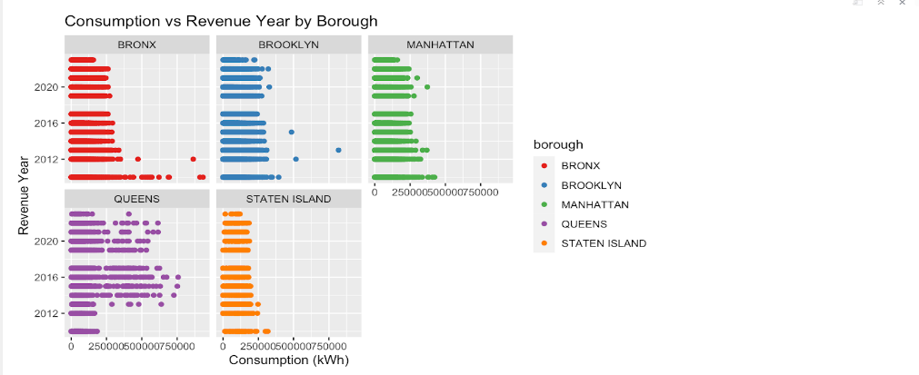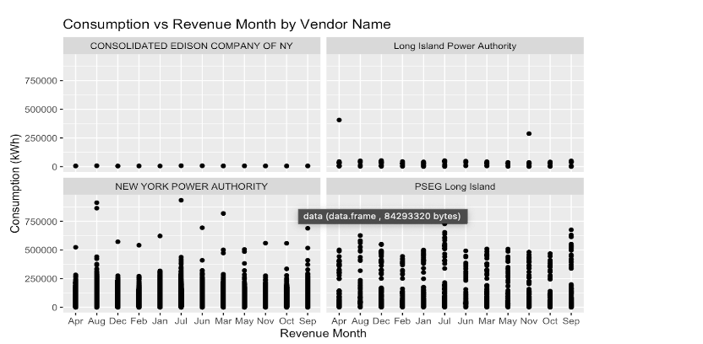  
  
The above graphs depict the consumption of electricity per year by the boroughs and revenue month by vendor name.

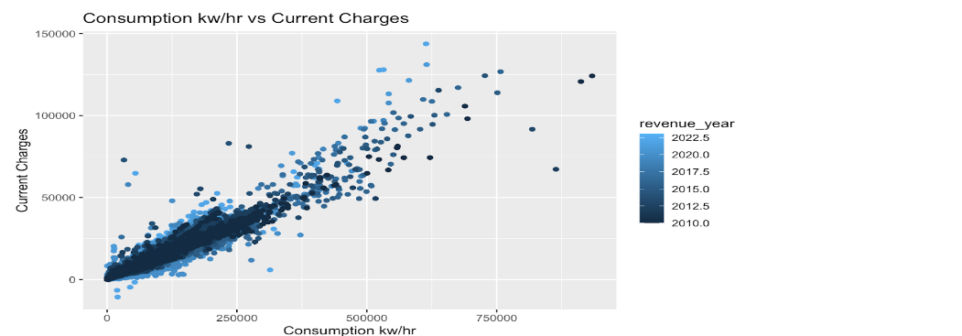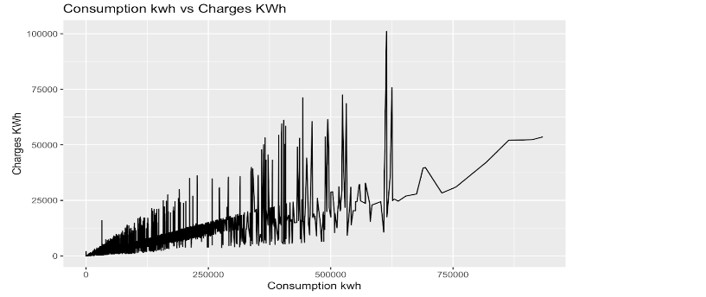  
The above graphs depict the consumption of current charges and charges kwh.

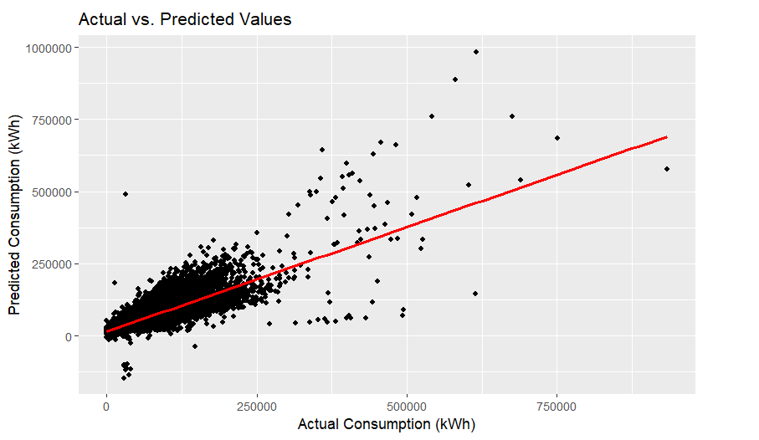 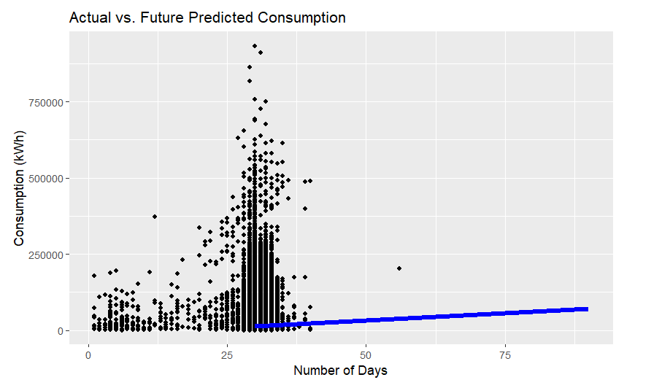

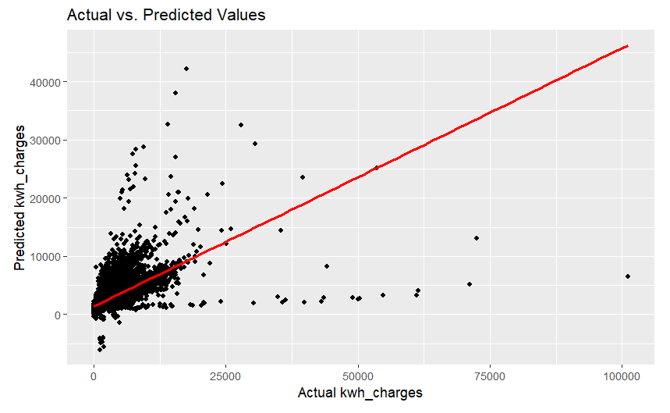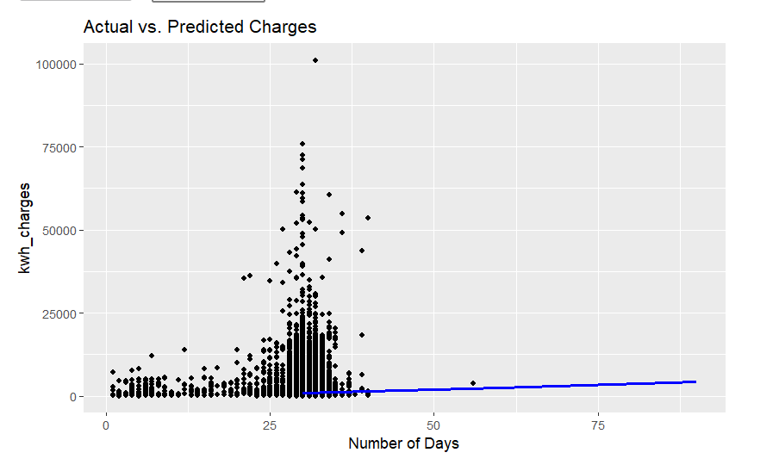

The above graphs show the Predictions and the future predictions by number of days.

RESULT

After analyzing the Electric Consumption and Cost data for New York City from 2010 to February 2023, several conclusions can be drawn:

1. The total electric consumption and cost have increased over time, with some fluctuations.

2. The residential sector consumes the highest amount of electricity, followed by the commercial and industrial sectors.

3. Manhattan has the highest electric consumption and cost among all the boroughs, followed by Brooklyn, Queens, the Bronx, and Staten Island.

4. The winter months have the highest electric consumption and cost, while the summer months have the lowest.

5. There is a positive correlation between electric consumption and cost, which is to be expected.

6. The implementation of energy efficiency measures and renewable energy sources can help reduce electric consumption and cost for the city.

Overall, this data analysis highlights the need for continued efforts to reduce energy consumption and cost in New York City, particularly in the residential sector. The data can be used to inform policies and initiatives aimed at promoting energy efficiency and sustainability in the city.